COMP2090SEF Group Project EECS S&T HKMU
COMP8090SEF/S209W Individual Project
Requirement on academic honesty (COMP2090SEF):
- Each group must make the following declaration on the cover page of the report
HongKong Metropolitan University
COMP2090SEF
Data Structures, Algorithms And Problem Solving
Course Project Report Group 62
Submission date:2026/4/16
We declare that:
  - all members of the group have read and checked that all parts of the project (including proposal, code programs, and reports), irrespective of whether they are contributed by individual member or all members as a group, here submitted is original except for source material explicitly acknowledged;
  - the project, in parts or in whole, has not been submitted for more than one purpose without declaration; (iii) we are aware of the University's policy and regulations on honesty in academic work and understand the possible consequence when breaching such policy and regulations;
  - we confirm that we have declared in the report about the usage of AI and other generative models, including but not limited to ChatGPT, LLaMA, Gemini, Mistral, and Stable Diffusion, and complied with the instructions provided by HKMU; and
  - we are aware that all members of the group should be held responsible and liable to disciplinary actions, irrespective of whether he/she has signed the declaration and whether he/she has contributed, directly or indirectly, to the problematic contents.
We confirm that we have read through and understood the project requirements. We understand that failure to comply with the project requirements will result in score deduction.
NAME | SID
Laiyutao | 13996440
Longenze | 14018180
ZhangWancen | 14002864
- The group must acknowledge ALL external resources or code from others referenced. We will only mark the parts that are original, not the parts from others.
- All members are liable to the plagiarism incidence, even if a free-rider.

Principle of Operation: How Radix Sort Works
Radix Sort is a non-comparative integer sorting algorithm [1]. Instead of comparing elements directly against one another, it sorts data by processing individual digits of the numbers sharing the same significant position and value.
The underlying principle relies on two core concepts: digit-by-digit processing and stable sub-sorting [2].
- Least Significant Digit (LSD) Approach: The algorithm processes the numbers starting from the Least Significant Digit (the rightmost digit, or units place) and progresses leftwards to the Most Significant Digit (the leftmost digit)[1].
- Bucket Distribution (Stable Sub-sort): For each digit position, the algorithm uses a stable sorting sub-routine. In a base-10 number system, it creates 10 "buckets" representing the digits 0 through 9. During a single pass, every number in the array is distributed into the bucket corresponding to its current digit's value.
- Sequential Collection: After all numbers are distributed for the current digit, they are collected out of the buckets in sequential order (from bucket 0 to bucket 9) and placed back into the main array.
- Preserving Relative Order (Stability): Because the collection process is stable, elements that share the exact same digit in the current pass maintain the
relative order they established in previous passes (which sorted their less significant digits). By the time the algorithm finishes processing the most significant digit of the largest number, the entire array is globally sorted.[2] For a visual step-by-step representation of the digit-by-digit processing and bucket distribution, please refer to the flowchart in Appendix A.

Time Complexity Analysis
The time complexity of Radix Sort is not determined by element comparisons, but strictly by the number of elements, the base of the numbering system, and the length of the largest number.[1] Let:
- n = the number of elements in the array
- d = the maximum number of digits in the largest element
- k = the base of the number system (for our decimal matrix, k=10)
Analysis per pass: During each iteration (i.e., for a single digit position), the algorithm performs two main operations:
- Iterating through all n elements to extract the target digit and distribute them into the k buckets. This takes O(n) time.
- Iterating through the k buckets to collect the elements back into the main array list. This takes O(k) time. Thus, a single pass takes O(n+k) time.[1]
Total Time Complexity: The algorithm must repeat this single-pass operation for every digit position in the largest number. Therefore, the distribution and collection phase executes exactly d times. Overall Time Complexity: Time Complexity=O(d (n+k))
- Best, Average, and Worst Case: O(d·(n+k)) Radix Sort does not possess a "shortcircuit" mechanism for already sorted arrays. It will consistently execute exactly dd passes across all n elements, making its best, average, and worstcase time complexities identical[2].
- Practical Implications: Because the base k is usually a small constant like 10, and the maximum number of digits dd is also small relative to n in many datasets, the time complexity simplifies to near linear time: O(n). This gives Radix Sort a significant theoretical advantage over comparative sorting algorithms like Merge Sort or Quick Sort (O(nlogn)) when handling massive datasets of comparable integers. [1]
Implement（Please refer to Appendix C for screenshots of our project demonstration, which includes test cases .）

the Radix Sort algorithm was implemented using basic built-in functions and list operations without relying on external sorting libraries. First, the max() built-in function was used to find the maximum value in the input array, which determines how many digit passes are needed. We used integer division (//) and modulus (%) to extract digits at different positions (units, tens, hundreds, etc.). For the bucket mechanism, we created a list of 10 empty lists (representing digits 0–9) to act as buckets; elements were distributed into these lists based on their current digit, then concatenated back into the main array in bucket order to form the sorted sequence after each pass.

For the matrix sorting implementation, the matrix was structured as a standard 2D nested list (no custom class was used in this version, keeping it lightweight). The sort_matrix_by_column function first extracts the target column using list comprehension, then sorts this column with the custom radix_sort function. A boolean used list was employed to track row usage and avoid duplicate row matching when reordering the matrix, ensuring correct row alignment even with duplicate column values. The matrix is initialized simply by passing a nested list of integers, with no special class constructor

Application example 1: Massive Integer Dataset Sorting for Big Data Analytics In big data platforms, log analysis, user behavior tracking, and financial transaction systems often generate hundreds of millions to billions of integerformat records (e.g., user IDs, transaction serial numbers, timestamps). These integers have fixed digit lengths and require fast, stable sorting for subsequent statistics and querying
. Process
Extract integer fields (user ID/transaction number) from the dataset.Use LSD
Radix Sort to sort from least significant digit to most significant digit Distribute elements into 10 buckets by current digit, collect sequentially, and repeat for all digit positions.Output sorted dataset for data analysis and query acceleration.

Application example 2: Multi-keyword Sorting for Electronic Document Indexing
Office systems, library management, and electronic archive platforms need to sort files/documents by multi-digit numbering (e.g., document number: 20260324001, book ISBN: 9787111642669). Multi-keyword stable sorting is required to ensure correct hierarchical order .
Process
Parse document numbers into independent digit positions (year, month, day, serial number).Apply Radix Sort from the lowest digit (serial number) to the highest digit (year) .Bucket distribution and sequential collection maintain stable order.Generate sorted document index list for quick retrieval and management.

Basic Principle of Matrix（A structural diagram of how this 2D nested list stores rows and manipulates columns can be found in Appendix B.）
A matrix is a 2D data structure for storing data in rows and columns. Each element can be found only by its row and column index. In Python, it is a nested list: the outer list for rows, inner lists for column values [5]. It is an extension of 1D arrays, used for structured tabular data storage and operations [4]. Main Method
In this code, the matrix is a non-empty 2D integer list, mainly to sort by a. specified column. Key steps: extract the target column as the sort key with list comprehension [5]; use a boolean list to mark row usage and solve reordering
problems from duplicate column values; match unmarked original rows with sorted column values and reorder into a new matrix; access and print elements with nested loops; use the custom radix sort to reorder the whole matrix by the sorted column [1].

Development
This code is a simple implementation for non-negative integer matrix operations and custom sorting, and it can be further optimized. Expand basic functions (add/delete rows/columns, transpose matrix, modify elements, check column index validity, etc.) [4]. Optimize sorting by binding rows with target column values, sort the pairs directly with radix sort to cut time complexity and remove the marking list [1]. Adjust radix sort to support floats and strings (instead of only non-negative integers); use multiple column values as keys for multi-column sorting; apply inplace sorting to modify the original matrix directly and save memory for large matrices [2].
This matrix (2D nested list) structure has two main practical uses:
ImplementTabular Data Storage & Analysis. It can store structured data simply, like student grades, inventory lists, or survey data. Each row stands for one item, and each column stands for a feature. This makes it easy to find and change single data points [4].
In the student grades example, the matrix works as a 2D table where each row contains the data for one specific student, and each column aligns with a specific subject. Because the data is structured this way, we can use built-in operations to calculate data across specific dimensions. When we run .mean(axis=1), the matrix calculates the average left-to-right across the columns for every row (giving each student's average). When we run .max(axis=0), it calculates the highest value top-to-bottom down every column (giving the highest score per subject).
Basic Data Structure for Programs. It is widely used in many computing tasks, such as image processing, map building, and basic math calculations. Its row-andcolumn structure helps us read and process multi-dimensional data easily in Python [5].
In the Tic-Tac-Toe example, the matrix works as a layout map for the game board by using a list of lists. Each slot on the board is represented by exact coordinate indices, [row][column], which store the current state (like 'X', 'O', or empty) of that specific square. To check if a player won on the main diagonal, the code works by using a single loop variable i to access matrix[i][i] (which targets spatial coordinates [0][0], [1][1], and [2][2]), checking if those specific spots contain the same player's symbol

Reference
- T. H. Cormen, C. E. Leiserson, R. L. Rivest, and C. Stein, Introduction to Algorithms, 3rd ed. Cambridge, MA, USA: MIT Press, 2009, pp. 197-200.
- R. Sedgewick and K. Wayne, Algorithms, 4th ed. Boston, MA, USA: AddisonWesley, 2011, pp. 702-710.
- D. E. Knuth, TheArt ofComputer Programming, Volume 3: Sorting and Searching, 2nd ed. Reading: Addison-Wesley, 1998.
- G. H. Golub and C. F. Van Loan, Matrix Computations, 4th ed. Baltimore: Johns Hopkins Univ. Press, 2013.
- M. T. Goodrich, R. Tamassia, and M. H. Goldwasser, Data Structures and Algorithms in Python. Hoboken: Wiley, 2013.

link to github: https://github.com/function03937-dev/-

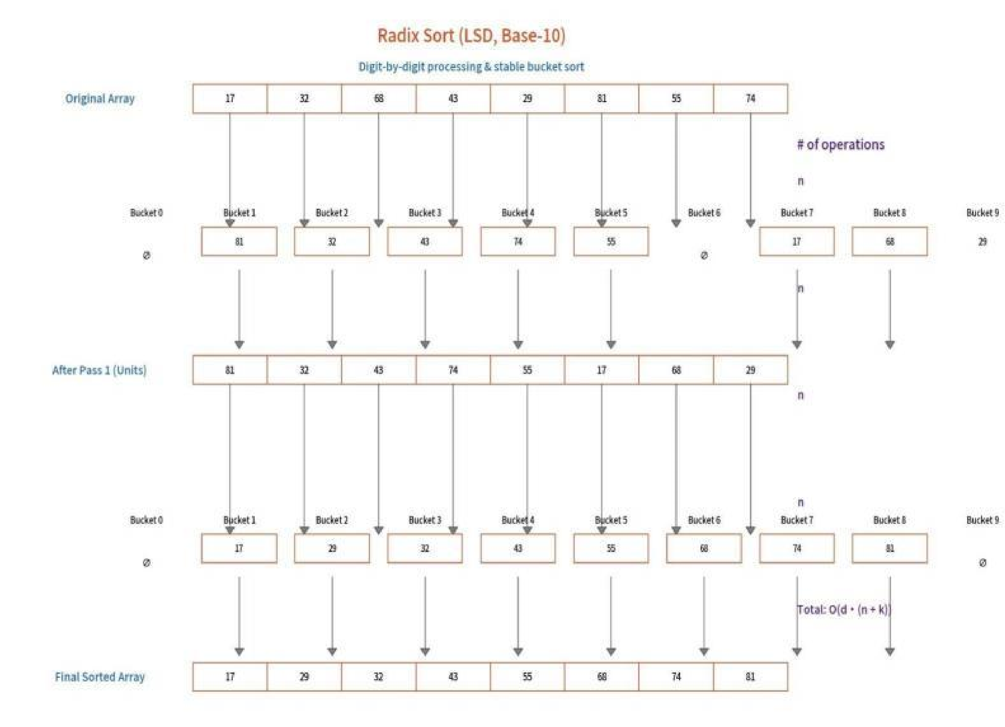
Appendix A Flow Chart of Radix Sort

Appendix B Matrix Data Structure Diagram
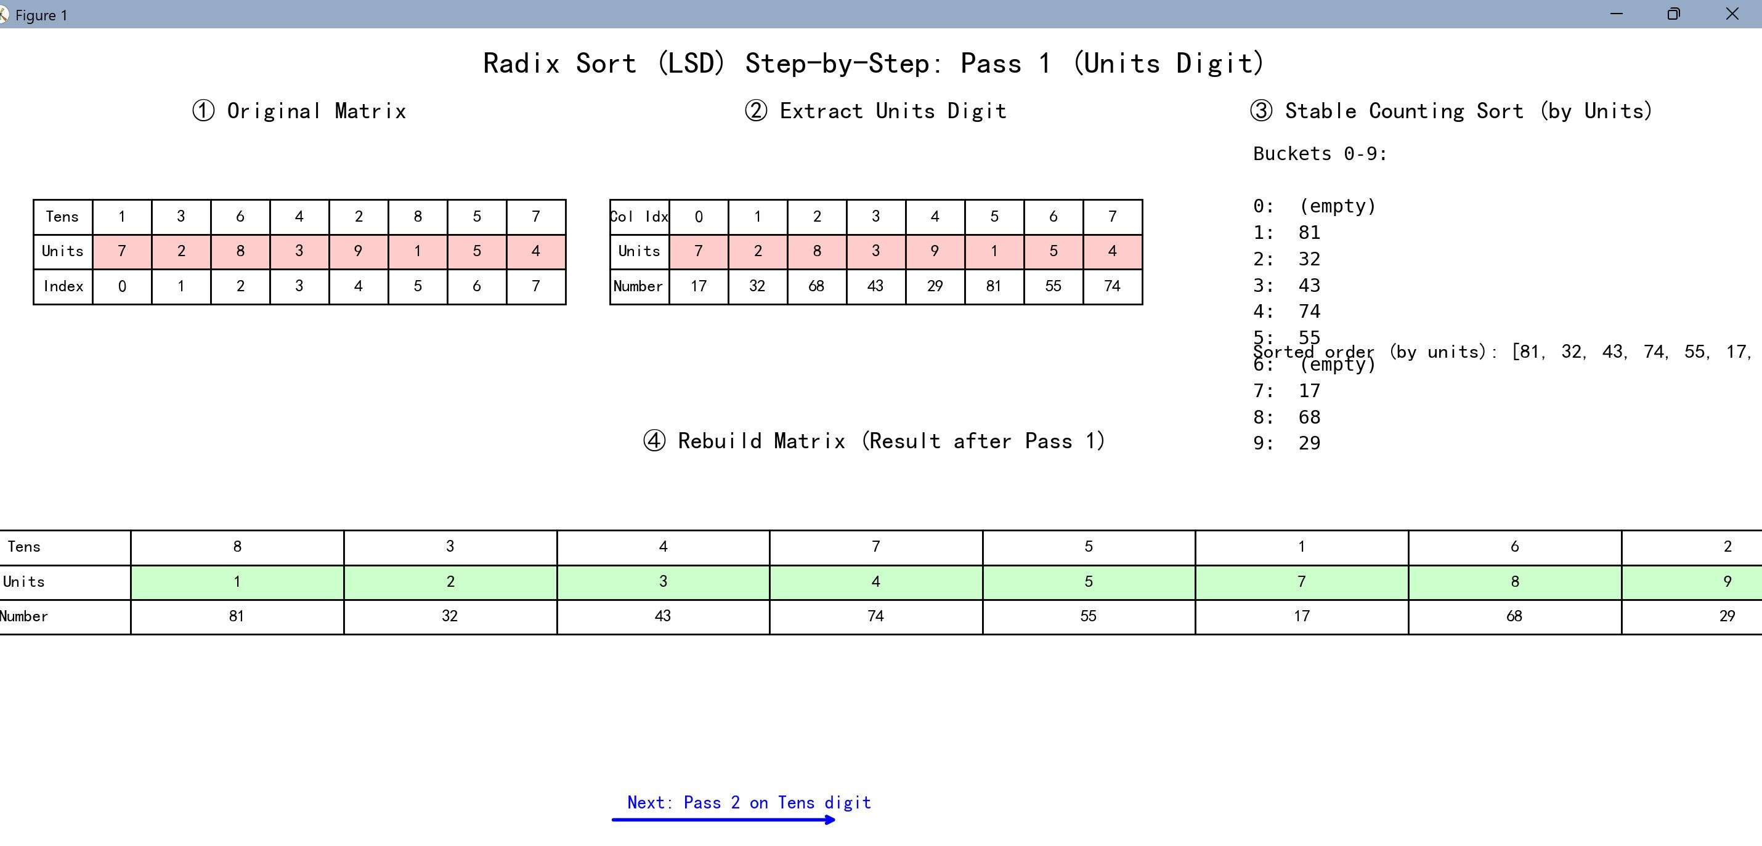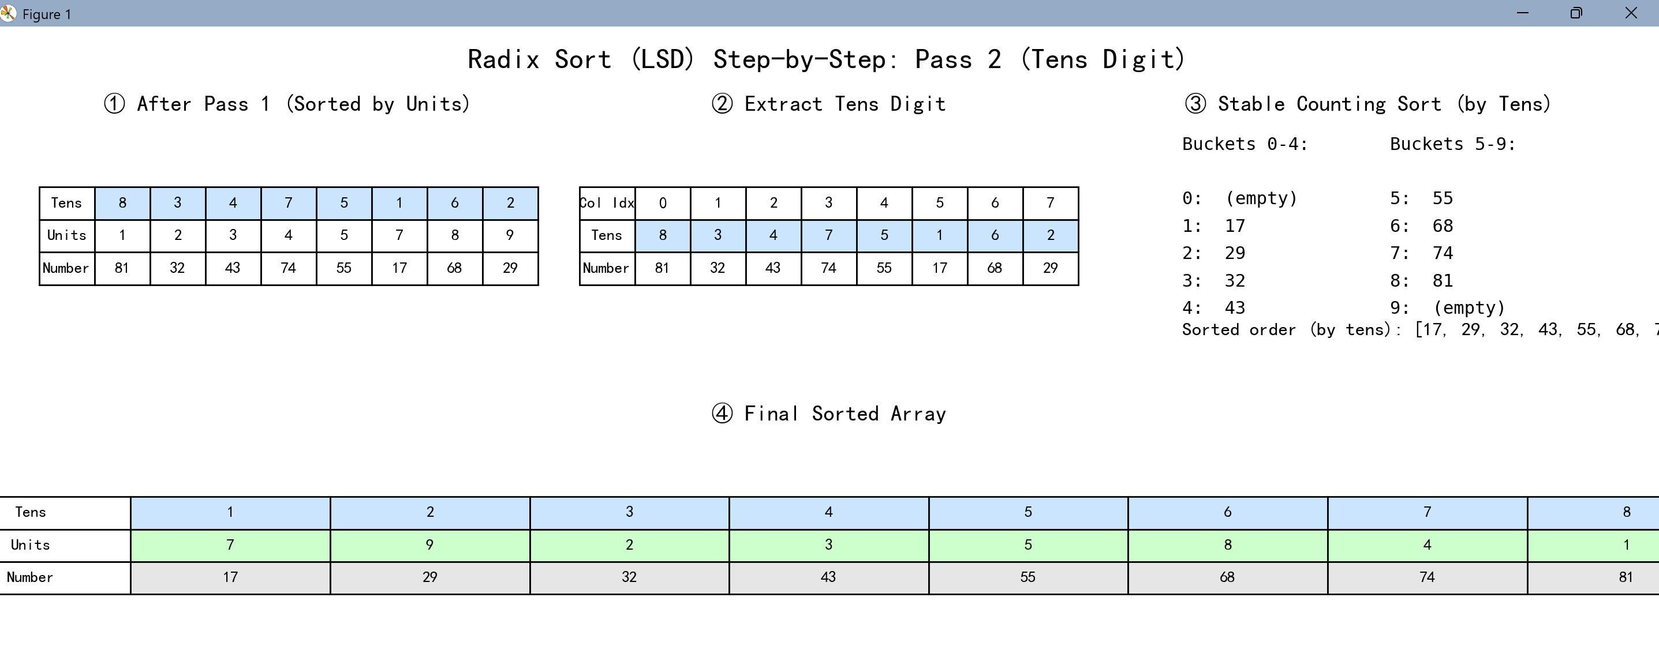

Appendix C Demonstration with Test Cases
Example of the radix sorting
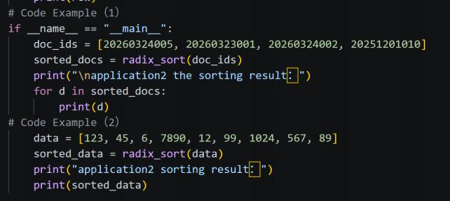
Example of matrix structure combining with radix sorting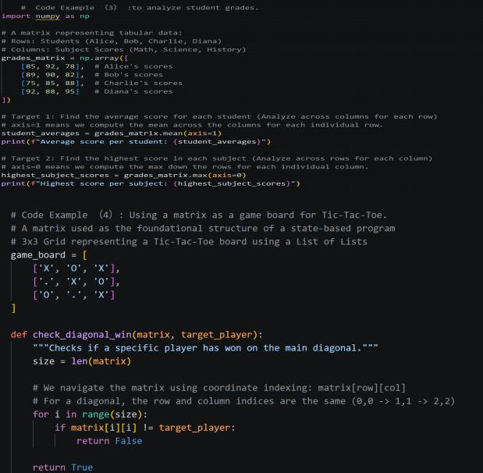

The Output of the function In Terminal
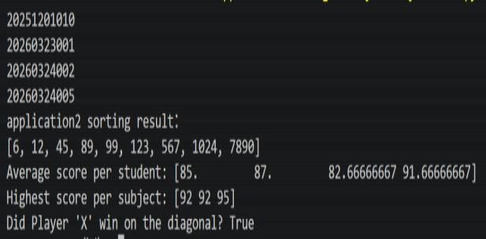
Example
1
The
sorted
Id
number
Example
2
The
sorted
data
Example
3
Example
4

Appendix D Core Code
Snippets
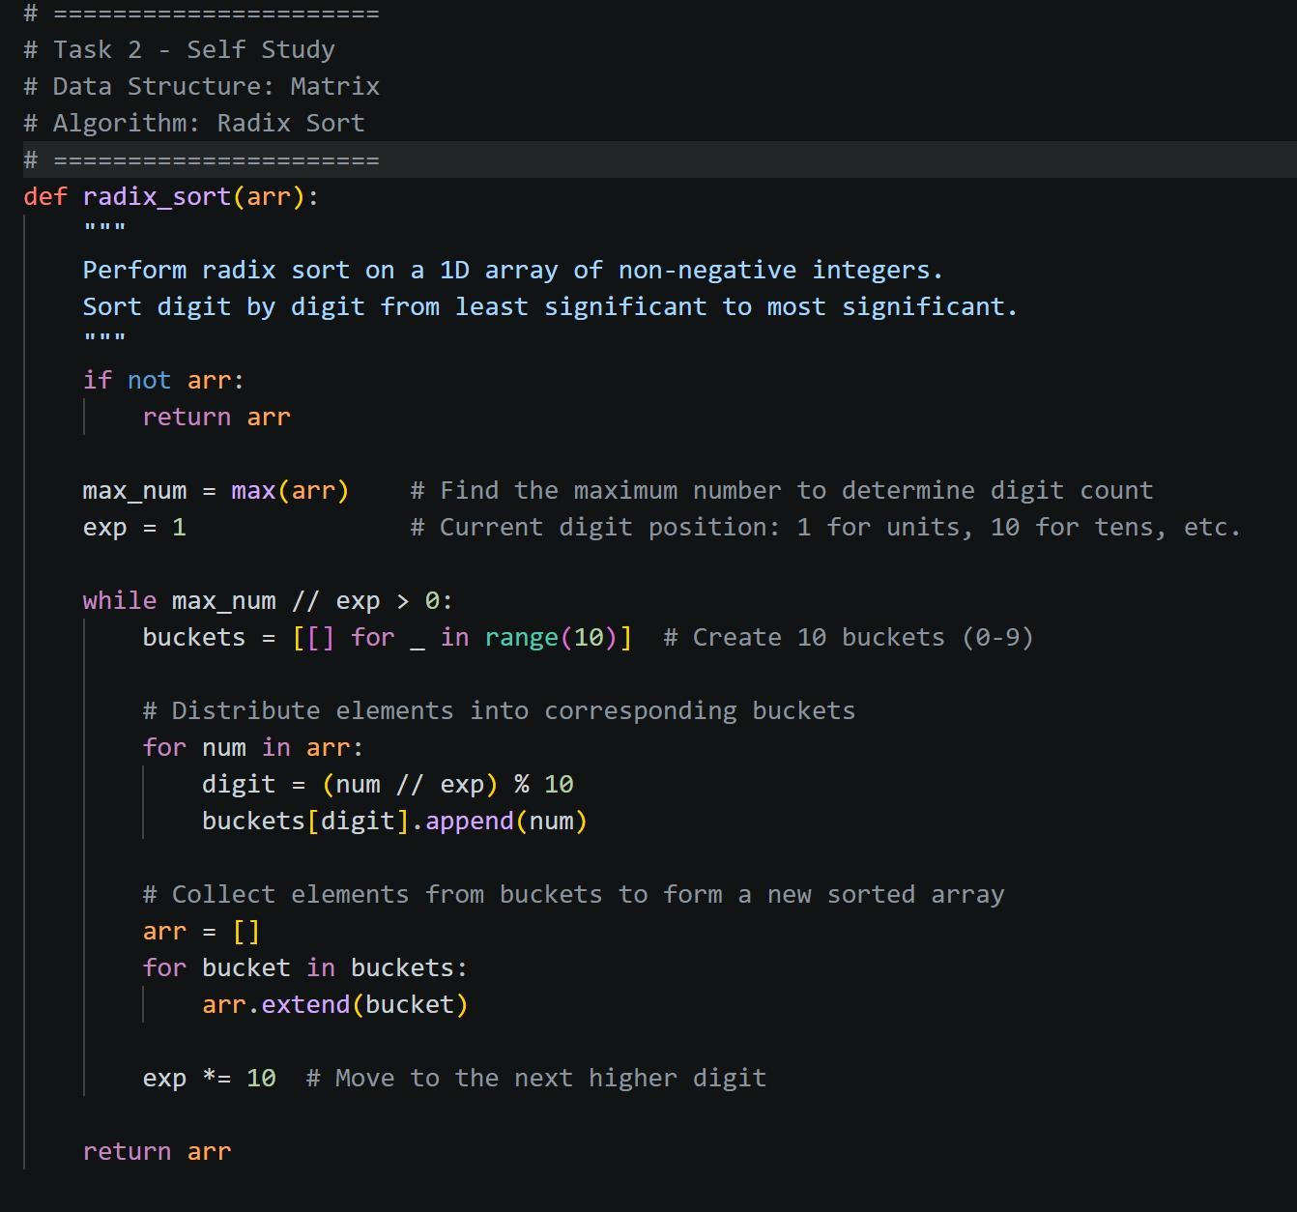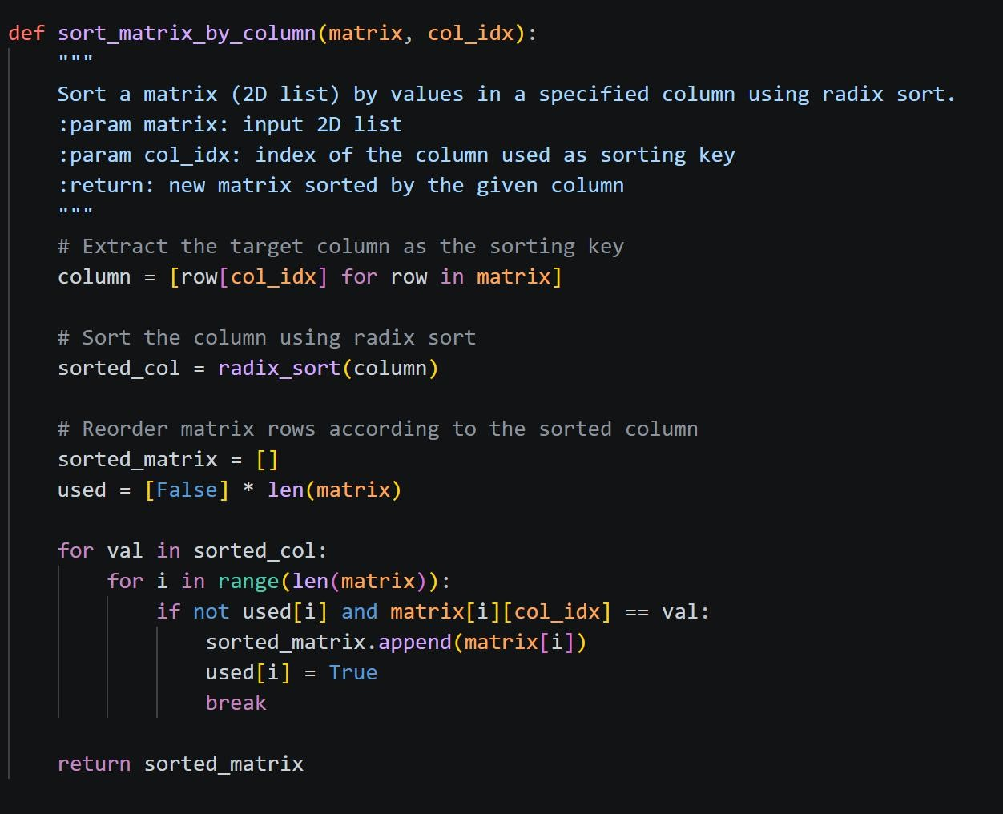

Appendix E Contribution Table
Contributor | Detailed Tasks | Percentage
ZhangWanCen | Radix Sort principle analysis, LSD mechanism explanation, stable sorting description | 34%
LongEnZe | Time complexity derivation, code implementation, big data application example, test case verification | 33%
LaiYuTao | Matrix theory explanation, report writing, IEEE reference formatting, language polishing, final submission arrangement | 33%

